UNITED STATES
SECURITIES AND EXCHANGE COMMISSION
Washington, D.C. 20549

FORM 8-K
CURRENT REPORT
Pursuant to Section 13 or 15(d)
of the Securities Exchange Act of 1934

Date of Report (Date of earliest event reported): April 25, 2024

CRONOS GROUP INC.
(Exact name of registrant as specified in its charter)
British Columbia, Canada |  |  | 001-38403 |  |  | N/A
(State or other jurisdiction |  |  | (Commission |  |  | (I.R.S. Employer
of incorporation) |  |  | File Number) |  |  | Identification No.)
111 Peter Street, Suite 300
Toronto , Ontario |  |  |  |  |  | M5V 2H1
(Address of principal executive offices) |  |  |  |  |  | (Zip Code)

Registrant’s telephone number, including area code: (416) 504-0004

Not Applicable
(Former name or former address, if changed since last report)
Check the appropriate box below if the Form 8-K filing is intended to simultaneously satisfy the filing obligation of the registrant under any of the following provisions:
☐ Written communications pursuant to Rule 425 under the Securities Act (17 CFR 230.425)
☐ Soliciting material pursuant to Rule 14a-12 under the Exchange Act (17 CFR 240.14a-12)
☐ Pre-commencement communications pursuant to Rule 14d-2(b) under the Exchange Act (17 CFR 240.14d-2(b))
☐ Pre-commencement communications pursuant to Rule 13e-4(c) under the Exchange Act (17 CFR 240.13e-4(c))
Securities registered pursuant to Section 12(b) of the Act:
Title of each class |  |  | Trading Symbol(s) |  |  | Name of each exchange on which registered
Common Shares, no par value |  |  | CRON |  |  | The NASDAQ Stock Market LLC

Indicate by check mark whether the registrant is an emerging growth company as defined in Rule 405 of the Securities Act of 1933 (§230.405 of this chapter) or Rule 12b-2 of the Securities Exchange Act of 1934 (§240.12b-2 of this chapter).
Emerging growth company ☐

If an emerging growth company, indicate by check mark if the registrant has elected not to use the extended transition period for complying with any new or revised financial accounting standards provided pursuant to Section 13(a) of the Exchange Act. ☐

Item 1.01. Entry into a Material Definitive Agreement.
On April 25, 2024, Cronos Group Inc. (the “Company”) entered into a voting agreement (the “Agreement”) with Altria Group, Inc. (“Altria”), which provides, among other things, that Altria will (i) be present in person or represented by proxy at the Company’s 2024 annual meeting of shareholders (the “2024 Annual Meeting”), (ii) vote, or cause to be voted, all of the common shares of the Company beneficially owned by Altria (the “Altria Shares”) at the 2024 Annual Meeting in favor of each of the Company’s proposals included in the Company’s definitive proxy statement (the “Proxy Statement”), as more specifically set forth in, and subject to the terms and conditions of, the Agreement (the “Proposals”), (iii) vote, or cause to be voted, all of the Altria Shares against any proposal to elect an individual other than a director nominee named in the Proxy Statement to the Company’s board of directors or any proposal inconsistent with any of the Company’s proposals included in the Proxy Statement and (iv) not solicit or participate in the solicitation of proxies against the Proposals or in favor of director nominees other than the below listed individuals, or knowingly encourage any person to do so. Altria’s obligation to vote, or cause to be voted, all of the Altria Shares in favor of the proposal to appoint the Company’s independent auditor (the “Auditor Proposal”) is subject to certain conditions, including Altria consultation and feedback rights.
Altria may terminate the Agreement if, among other things, the Company fails to nominate for election as directors to the Company’s board of directors Kamran Khan, Dominik Meier, Elizabeth Seegar and Murray Garnick, each of whom have been designated by Altria to the Company as Altria’s director nominees, and Michael Gorenstein, Jason Adler and James Rudyk. The Agreement will automatically terminate no later than the earlier of (i) September 26, 2024 and (ii) the Company’s filing of a Current Report on Form 8-K announcing the final voting results of each proposal at the 2024 Annual Meeting, including, the Company’s filing of a Current Report on Form 8-K announcing the final voting results of the Auditor Proposal.
The foregoing description of the Agreement does not purport to be complete and is subject to, and qualified in its entirety by, the full text of the Agreement, a copy of which is attached to this Current Report on Form 8-K as Exhibit 10.1 and is incorporated into this Item 1.01 by reference in its entirety. The Agreement has been attached to provide investors with information regarding its terms. It is not intended to provide any other factual or disclosure information about the Company or Altria. The Agreement contains representations, warranties and covenants by the Company and Altria, and those representations, warranties and covenants may apply standards of materiality in a way that is different from what may be viewed as material to the reader or other investors. Accordingly, investors should not rely on the representations, warranties and covenants in the Agreement, or any description thereof, as characterizations of the actual state of facts or conditions. Investors should review the Agreement, or any descriptions thereof, not in isolation, but only in conjunction with the other information about the Company that it includes in reports, statements and other filings it makes with the Securities and Exchange Commission.

Item 9.01. Financial Statements and Exhibits.
(d) Exhibits.
Exhibit No. |  |  |  |  |  | Description
10.1* |  |  |  |  |  | Voting Agreement, dated as of April 25, 2024, by and between Cronos Group Inc. and Altria Group, Inc.
104 |  |  |  |  |  | Cover Page Interactive Data File – The cover page from Cronos Group Inc.’s Current Report on Form 8-K filed on April 25, 2024 is formatted in Inline XBRL.

*Certain schedules (or similar attachments) have been omitted pursuant to Item 601(b)(2) of Regulation S-K. The registrant agrees to furnish supplementally a copy of any such omitted schedule or other attachment to the SEC upon its request.

SIGNATURES

Pursuant to the requirements of the Securities Exchange Act of 1934, the registrant has duly caused this report to be signed on its behalf by the undersigned hereunto duly authorized.
 |  |  |  |  |  | CRONOS GROUP INC.
Dated: April 25, 2024 |  |  |  |  |  | By: |  |  | /s/ Michael Gorenstein
 |  |  |  |  |  |  |  |  | Name: Michael Gorenstein
 |  |  |  |  |  |  |  |  | Title: President and Chief Executive Officer

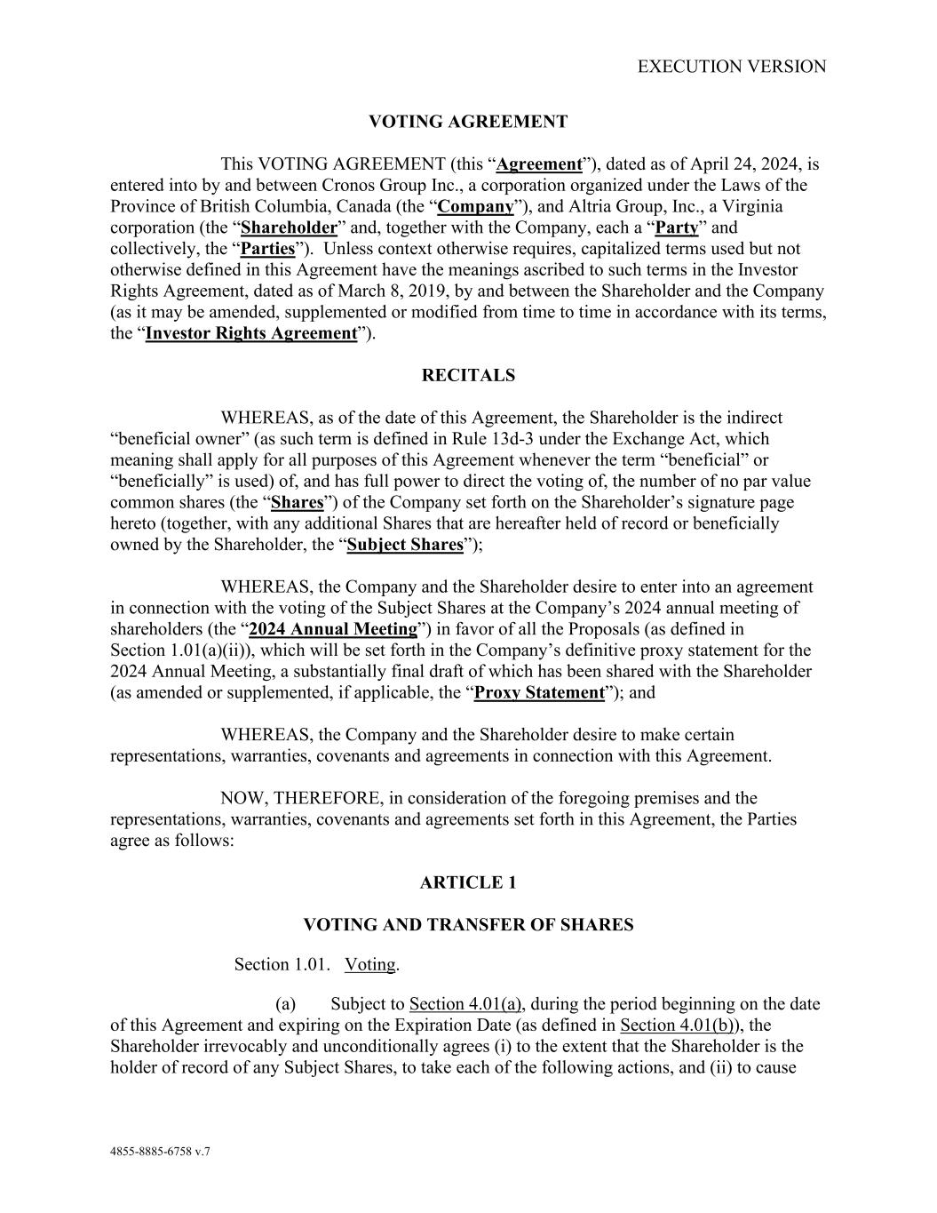

EXECUTION VERSION 4855-8885-6758 v.7 VOTING AGREEMENT This VOTING AGREEMENT (this “Agreement”), dated as of April 24, 2024, is entered into by and between Cronos Group Inc., a corporation organized under the Laws of the Province of British Columbia, Canada (the “Company”), and Altria Group, Inc., a Virginia corporation (the “Shareholder” and, together with the Company, each a “Party” and collectively, the “Parties”). Unless context otherwise requires, capitalized terms used but not otherwise defined in this Agreement have the meanings ascribed to such terms in the Investor Rights Agreement, dated as of March 8, 2019, by and between the Shareholder and the Company (as it may be amended, supplemented or modified from time to time in accordance with its terms, the “Investor Rights Agreement”). RECITALS WHEREAS, as of the date of this Agreement, the Shareholder is the indirect “beneficial owner” (as such term is defined in Rule 13d-3 under the Exchange Act, which meaning shall apply for all purposes of this Agreement whenever the term “beneficial” or “beneficially” is used) of, and has full power to direct the voting of, the number of no par value common shares (the “Shares”) of the Company set forth on the Shareholder’s signature page hereto (together, with any additional Shares that are hereafter held of record or beneficially owned by the Shareholder, the “Subject Shares”); WHEREAS, the Company and the Shareholder desire to enter into an agreement in connection with the voting of the Subject Shares at the Company’s 2024 annual meeting of shareholders (the “2024 Annual Meeting”) in favor of all the Proposals (as defined in Section 1.01(a)(ii)), which will be set forth in the Company’s definitive proxy statement for the 2024 Annual Meeting, a substantially final draft of which has been shared with the Shareholder (as amended or supplemented, if applicable, the “Proxy Statement”); and WHEREAS, the Company and the Shareholder desire to make certain representations, warranties, covenants and agreements in connection with this Agreement. NOW, THEREFORE, in consideration of the foregoing premises and the representations, warranties, covenants and agreements set forth in this Agreement, the Parties agree as follows: ARTICLE 1 VOTING AND TRANSFER OF SHARES Section 1.01. Voting. (a) Subject to Section 4.01(a), during the period beginning on the date of this Agreement and expiring on the Expiration Date (as defined in Section 4.01(b)), the Shareholder irrevocably and unconditionally agrees (i) to the extent that the Shareholder is the holder of record of any Subject Shares, to take each of the following actions, and (ii) to cause

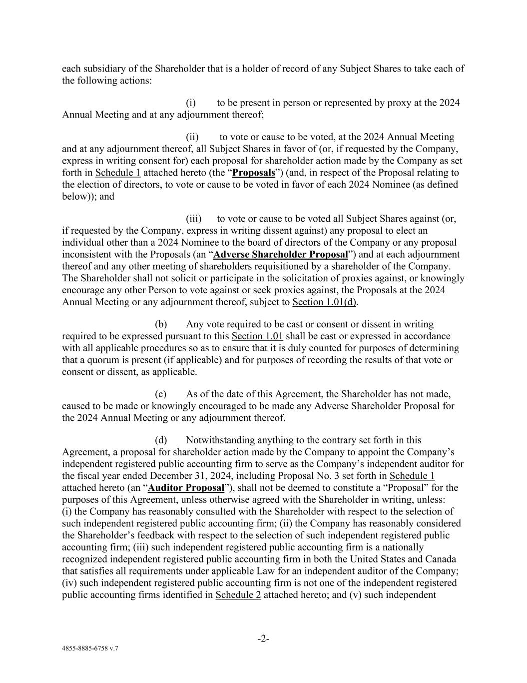
-2- 4855-8885-6758 v.7 each subsidiary of the Shareholder that is a holder of record of any Subject Shares to take each of the following actions: (i) to be present in person or represented by proxy at the 2024 Annual Meeting and at any adjournment thereof; (ii) to vote or cause to be voted, at the 2024 Annual Meeting and at any adjournment thereof, all Subject Shares in favor of (or, if requested by the Company, express in writing consent for) each proposal for shareholder action made by the Company as set forth in Schedule 1 attached hereto (the “Proposals”) (and, in respect of the Proposal relating to the election of directors, to vote or cause to be voted in favor of each 2024 Nominee (as defined below)); and (iii) to vote or cause to be voted all Subject Shares against (or, if requested by the Company, express in writing dissent against) any proposal to elect an individual other than a 2024 Nominee to the board of directors of the Company or any proposal inconsistent with the Proposals (an “Adverse Shareholder Proposal”) and at each adjournment thereof and any other meeting of shareholders requisitioned by a shareholder of the Company. The Shareholder shall not solicit or participate in the solicitation of proxies against, or knowingly encourage any other Person to vote against or seek proxies against, the Proposals at the 2024 Annual Meeting or any adjournment thereof, subject to Section 1.01(d). (b) Any vote required to be cast or consent or dissent in writing required to be expressed pursuant to this Section 1.01 shall be cast or expressed in accordance with all applicable procedures so as to ensure that it is duly counted for purposes of determining that a quorum is present (if applicable) and for purposes of recording the results of that vote or consent or dissent, as applicable. (c) As of the date of this Agreement, the Shareholder has not made, caused to be made or knowingly encouraged to be made any Adverse Shareholder Proposal for the 2024 Annual Meeting or any adjournment thereof. (d) Notwithstanding anything to the contrary set forth in this Agreement, a proposal for shareholder action made by the Company to appoint the Company’s independent registered public accounting firm to serve as the Company’s independent auditor for the fiscal year ended December 31, 2024, including Proposal No. 3 set forth in Schedule 1 attached hereto (an “Auditor Proposal”), shall not be deemed to constitute a “Proposal” for the purposes of this Agreement, unless otherwise agreed with the Shareholder in writing, unless: (i) the Company has reasonably consulted with the Shareholder with respect to the selection of such independent registered public accounting firm; (ii) the Company has reasonably considered the Shareholder’s feedback with respect to the selection of such independent registered public accounting firm; (iii) such independent registered public accounting firm is a nationally recognized independent registered public accounting firm in both the United States and Canada that satisfies all requirements under applicable Law for an independent auditor of the Company; (iv) such independent registered public accounting firm is not one of the independent registered public accounting firms identified in Schedule 2 attached hereto; and (v) such independent

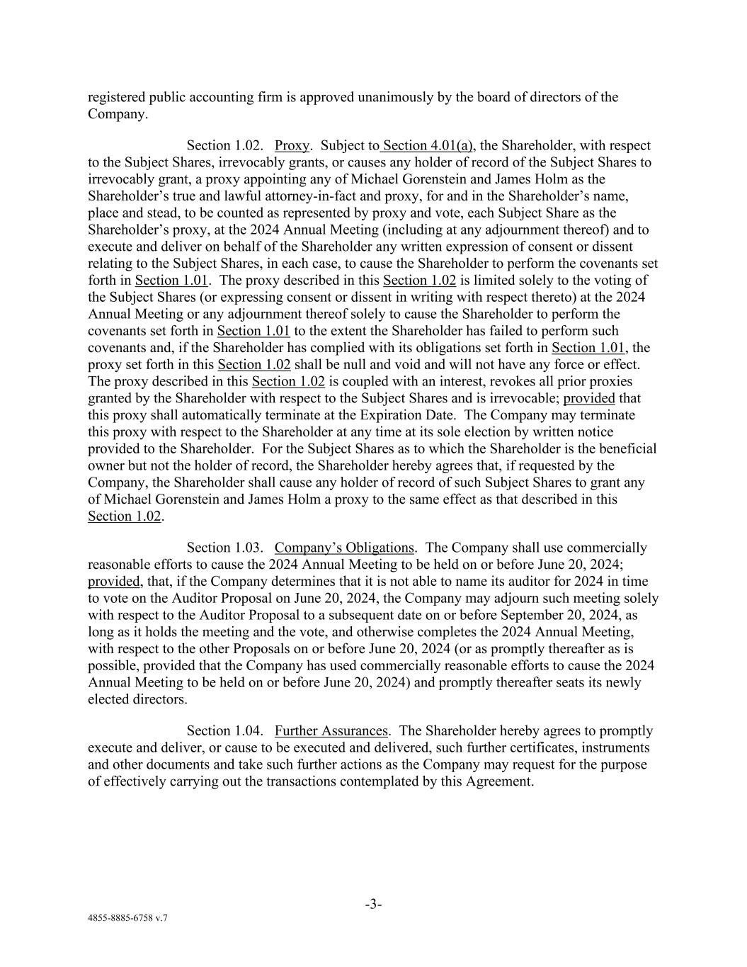
-3- 4855-8885-6758 v.7 registered public accounting firm is approved unanimously by the board of directors of the Company. Section 1.02. Proxy. Subject to Section 4.01(a), the Shareholder, with respect to the Subject Shares, irrevocably grants, or causes any holder of record of the Subject Shares to irrevocably grant, a proxy appointing any of Michael Gorenstein and James Holm as the Shareholder’s true and lawful attorney-in-fact and proxy, for and in the Shareholder’s name, place and stead, to be counted as represented by proxy and vote, each Subject Share as the Shareholder’s proxy, at the 2024 Annual Meeting (including at any adjournment thereof) and to execute and deliver on behalf of the Shareholder any written expression of consent or dissent relating to the Subject Shares, in each case, to cause the Shareholder to perform the covenants set forth in Section 1.01. The proxy described in this Section 1.02 is limited solely to the voting of the Subject Shares (or expressing consent or dissent in writing with respect thereto) at the 2024 Annual Meeting or any adjournment thereof solely to cause the Shareholder to perform the covenants set forth in Section 1.01 to the extent the Shareholder has failed to perform such covenants and, if the Shareholder has complied with its obligations set forth in Section 1.01, the proxy set forth in this Section 1.02 shall be null and void and will not have any force or effect. The proxy described in this Section 1.02 is coupled with an interest, revokes all prior proxies granted by the Shareholder with respect to the Subject Shares and is irrevocable; provided that this proxy shall automatically terminate at the Expiration Date. The Company may terminate this proxy with respect to the Shareholder at any time at its sole election by written notice provided to the Shareholder. For the Subject Shares as to which the Shareholder is the beneficial owner but not the holder of record, the Shareholder hereby agrees that, if requested by the Company, the Shareholder shall cause any holder of record of such Subject Shares to grant any of Michael Gorenstein and James Holm a proxy to the same effect as that described in this Section 1.02. Section 1.03. Company’s Obligations. The Company shall use commercially reasonable efforts to cause the 2024 Annual Meeting to be held on or before June 20, 2024; provided, that, if the Company determines that it is not able to name its auditor for 2024 in time to vote on the Auditor Proposal on June 20, 2024, the Company may adjourn such meeting solely with respect to the Auditor Proposal to a subsequent date on or before September 20, 2024, as long as it holds the meeting and the vote, and otherwise completes the 2024 Annual Meeting, with respect to the other Proposals on or before June 20, 2024 (or as promptly thereafter as is possible, provided that the Company has used commercially reasonable efforts to cause the 2024 Annual Meeting to be held on or before June 20, 2024) and promptly thereafter seats its newly elected directors. Section 1.04. Further Assurances. The Shareholder hereby agrees to promptly execute and deliver, or cause to be executed and delivered, such further certificates, instruments and other documents and take such further actions as the Company may request for the purpose of effectively carrying out the transactions contemplated by this Agreement.

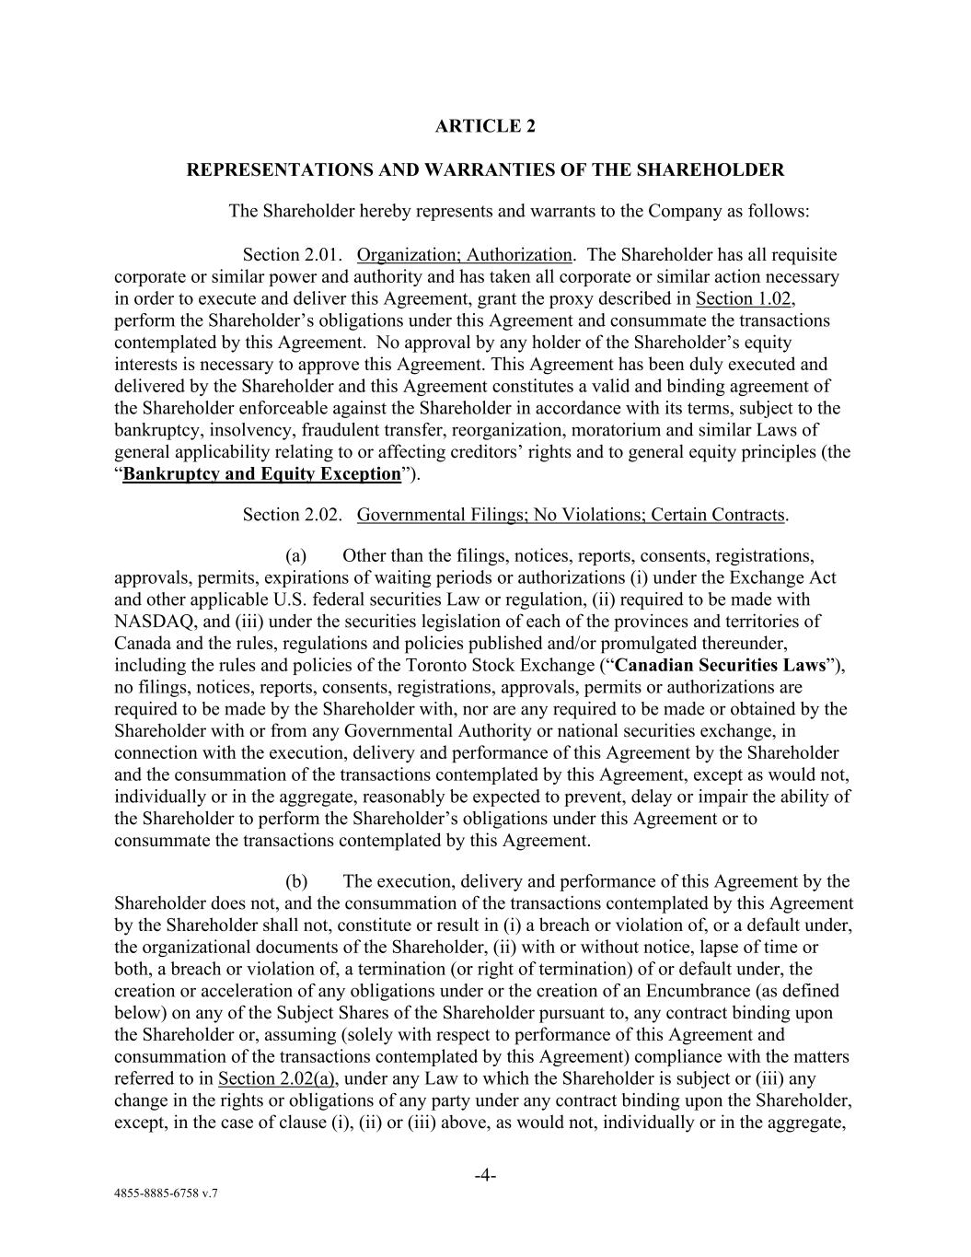
-4- 4855-8885-6758 v.7 ARTICLE 2 REPRESENTATIONS AND WARRANTIES OF THE SHAREHOLDER The Shareholder hereby represents and warrants to the Company as follows: Section 2.01. Organization; Authorization. The Shareholder has all requisite corporate or similar power and authority and has taken all corporate or similar action necessary in order to execute and deliver this Agreement, grant the proxy described in Section 1.02, perform the Shareholder’s obligations under this Agreement and consummate the transactions contemplated by this Agreement. No approval by any holder of the Shareholder’s equity interests is necessary to approve this Agreement. This Agreement has been duly executed and delivered by the Shareholder and this Agreement constitutes a valid and binding agreement of the Shareholder enforceable against the Shareholder in accordance with its terms, subject to the bankruptcy, insolvency, fraudulent transfer, reorganization, moratorium and similar Laws of general applicability relating to or affecting creditors’ rights and to general equity principles (the “Bankruptcy and Equity Exception”). Section 2.02. Governmental Filings; No Violations; Certain Contracts. (a) Other than the filings, notices, reports, consents, registrations, approvals, permits, expirations of waiting periods or authorizations (i) under the Exchange Act and other applicable U.S. federal securities Law or regulation, (ii) required to be made with NASDAQ, and (iii) under the securities legislation of each of the provinces and territories of Canada and the rules, regulations and policies published and/or promulgated thereunder, including the rules and policies of the Toronto Stock Exchange (“Canadian Securities Laws”), no filings, notices, reports, consents, registrations, approvals, permits or authorizations are required to be made by the Shareholder with, nor are any required to be made or obtained by the Shareholder with or from any Governmental Authority or national securities exchange, in connection with the execution, delivery and performance of this Agreement by the Shareholder and the consummation of the transactions contemplated by this Agreement, except as would not, individually or in the aggregate, reasonably be expected to prevent, delay or impair the ability of the Shareholder to perform the Shareholder’s obligations under this Agreement or to consummate the transactions contemplated by this Agreement. (b) The execution, delivery and performance of this Agreement by the Shareholder does not, and the consummation of the transactions contemplated by this Agreement by the Shareholder shall not, constitute or result in (i) a breach or violation of, or a default under, the organizational documents of the Shareholder, (ii) with or without notice, lapse of time or both, a breach or violation of, a termination (or right of termination) of or default under, the creation or acceleration of any obligations under or the creation of an Encumbrance (as defined below) on any of the Subject Shares of the Shareholder pursuant to, any contract binding upon the Shareholder or, assuming (solely with respect to performance of this Agreement and consummation of the transactions contemplated by this Agreement) compliance with the matters referred to in Section 2.02(a), under any Law to which the Shareholder is subject or (iii) any change in the rights or obligations of any party under any contract binding upon the Shareholder, except, in the case of clause (i), (ii) or (iii) above, as would not, individually or in the aggregate,

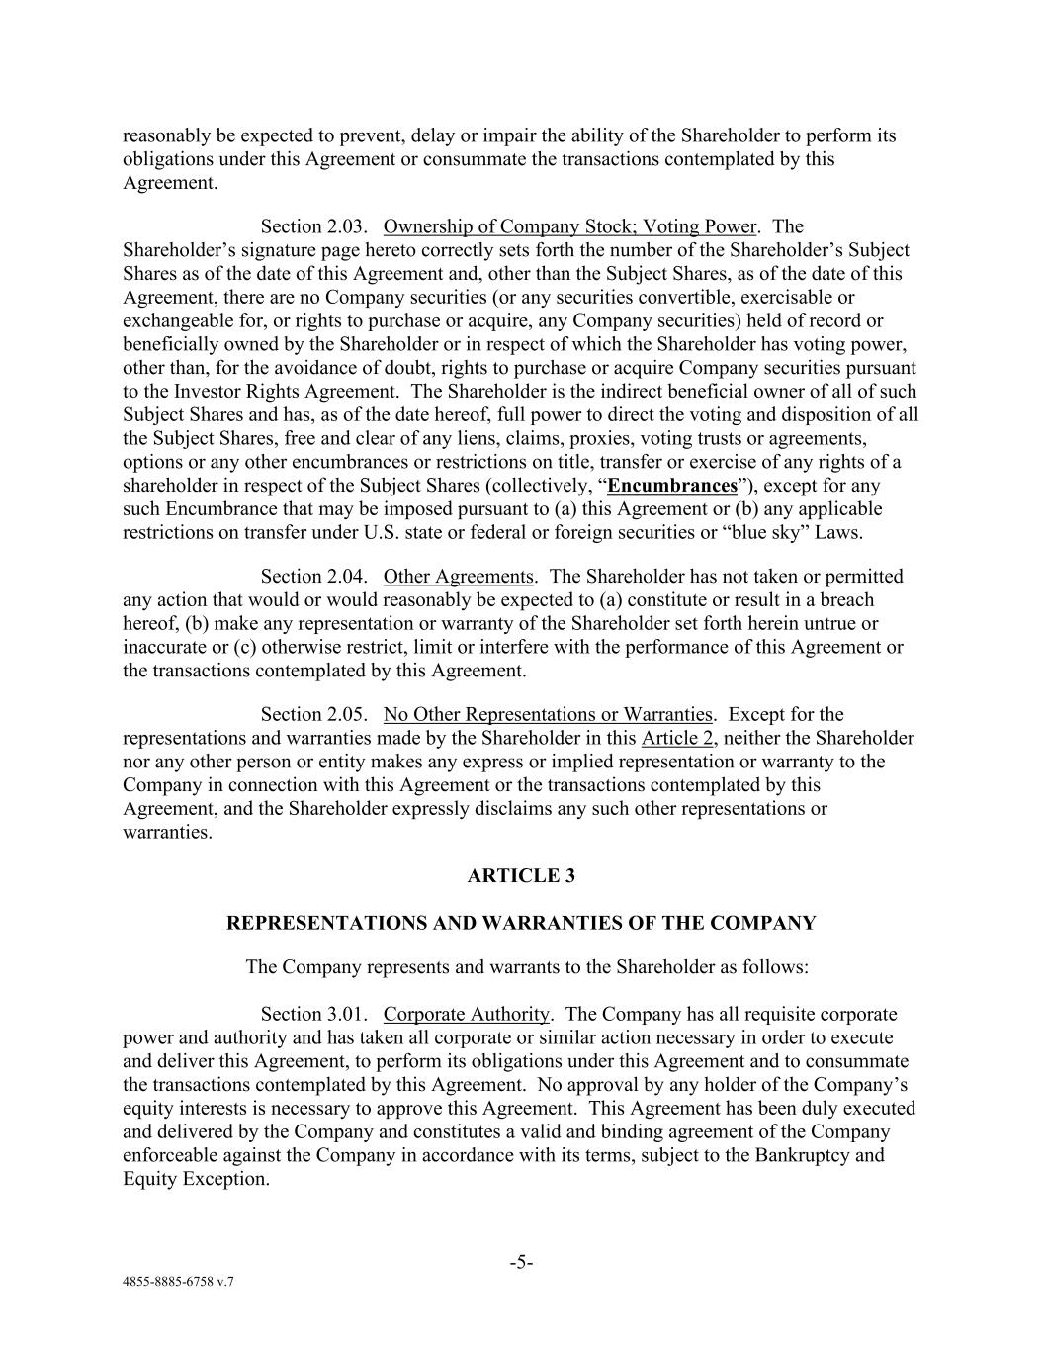
-5- 4855-8885-6758 v.7 reasonably be expected to prevent, delay or impair the ability of the Shareholder to perform its obligations under this Agreement or consummate the transactions contemplated by this Agreement. Section 2.03. Ownership of Company Stock; Voting Power. The Shareholder’s signature page hereto correctly sets forth the number of the Shareholder’s Subject Shares as of the date of this Agreement and, other than the Subject Shares, as of the date of this Agreement, there are no Company securities (or any securities convertible, exercisable or exchangeable for, or rights to purchase or acquire, any Company securities) held of record or beneficially owned by the Shareholder or in respect of which the Shareholder has voting power, other than, for the avoidance of doubt, rights to purchase or acquire Company securities pursuant to the Investor Rights Agreement. The Shareholder is the indirect beneficial owner of all of such Subject Shares and has, as of the date hereof, full power to direct the voting and disposition of all the Subject Shares, free and clear of any liens, claims, proxies, voting trusts or agreements, options or any other encumbrances or restrictions on title, transfer or exercise of any rights of a shareholder in respect of the Subject Shares (collectively, “Encumbrances”), except for any such Encumbrance that may be imposed pursuant to (a) this Agreement or (b) any applicable restrictions on transfer under U.S. state or federal or foreign securities or “blue sky” Laws. Section 2.04. Other Agreements. The Shareholder has not taken or permitted any action that would or would reasonably be expected to (a) constitute or result in a breach hereof, (b) make any representation or warranty of the Shareholder set forth herein untrue or inaccurate or (c) otherwise restrict, limit or interfere with the performance of this Agreement or the transactions contemplated by this Agreement. Section 2.05. No Other Representations or Warranties. Except for the representations and warranties made by the Shareholder in this Article 2, neither the Shareholder nor any other person or entity makes any express or implied representation or warranty to the Company in connection with this Agreement or the transactions contemplated by this Agreement, and the Shareholder expressly disclaims any such other representations or warranties. ARTICLE 3 REPRESENTATIONS AND WARRANTIES OF THE COMPANY The Company represents and warrants to the Shareholder as follows: Section 3.01. Corporate Authority. The Company has all requisite corporate power and authority and has taken all corporate or similar action necessary in order to execute and deliver this Agreement, to perform its obligations under this Agreement and to consummate the transactions contemplated by this Agreement. No approval by any holder of the Company’s equity interests is necessary to approve this Agreement. This Agreement has been duly executed and delivered by the Company and constitutes a valid and binding agreement of the Company enforceable against the Company in accordance with its terms, subject to the Bankruptcy and Equity Exception.

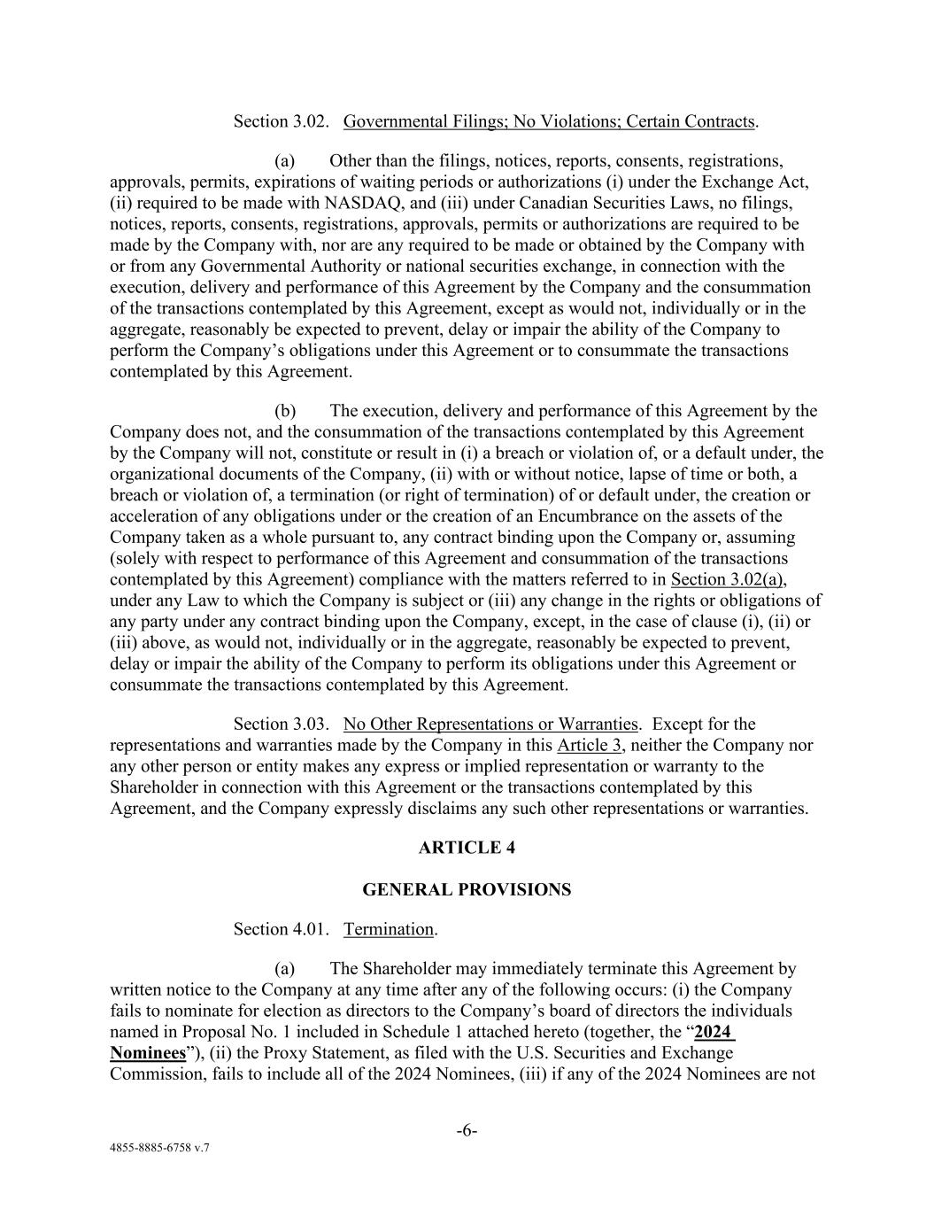
-6- 4855-8885-6758 v.7 Section 3.02. Governmental Filings; No Violations; Certain Contracts. (a) Other than the filings, notices, reports, consents, registrations, approvals, permits, expirations of waiting periods or authorizations (i) under the Exchange Act, (ii) required to be made with NASDAQ, and (iii) under Canadian Securities Laws, no filings, notices, reports, consents, registrations, approvals, permits or authorizations are required to be made by the Company with, nor are any required to be made or obtained by the Company with or from any Governmental Authority or national securities exchange, in connection with the execution, delivery and performance of this Agreement by the Company and the consummation of the transactions contemplated by this Agreement, except as would not, individually or in the aggregate, reasonably be expected to prevent, delay or impair the ability of the Company to perform the Company’s obligations under this Agreement or to consummate the transactions contemplated by this Agreement. (b) The execution, delivery and performance of this Agreement by the Company does not, and the consummation of the transactions contemplated by this Agreement by the Company will not, constitute or result in (i) a breach or violation of, or a default under, the organizational documents of the Company, (ii) with or without notice, lapse of time or both, a breach or violation of, a termination (or right of termination) of or default under, the creation or acceleration of any obligations under or the creation of an Encumbrance on the assets of the Company taken as a whole pursuant to, any contract binding upon the Company or, assuming (solely with respect to performance of this Agreement and consummation of the transactions contemplated by this Agreement) compliance with the matters referred to in Section 3.02(a), under any Law to which the Company is subject or (iii) any change in the rights or obligations of any party under any contract binding upon the Company, except, in the case of clause (i), (ii) or (iii) above, as would not, individually or in the aggregate, reasonably be expected to prevent, delay or impair the ability of the Company to perform its obligations under this Agreement or consummate the transactions contemplated by this Agreement. Section 3.03. No Other Representations or Warranties. Except for the representations and warranties made by the Company in this Article 3, neither the Company nor any other person or entity makes any express or implied representation or warranty to the Shareholder in connection with this Agreement or the transactions contemplated by this Agreement, and the Company expressly disclaims any such other representations or warranties. ARTICLE 4 GENERAL PROVISIONS Section 4.01. Termination. (a) The Shareholder may immediately terminate this Agreement by written notice to the Company at any time after any of the following occurs: (i) the Company fails to nominate for election as directors to the Company’s board of directors the individuals named in Proposal No. 1 included in Schedule 1 attached hereto (together, the “2024 Nominees”), (ii) the Proxy Statement, as filed with the U.S. Securities and Exchange Commission, fails to include all of the 2024 Nominees, (iii) if any of the 2024 Nominees are not

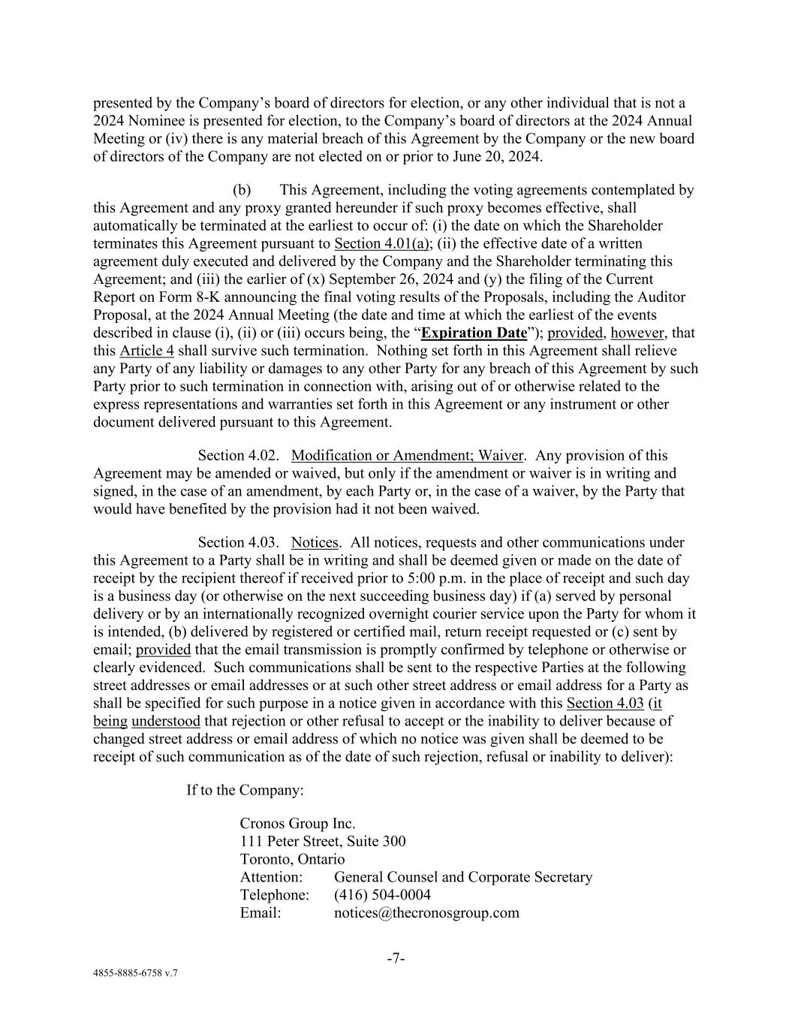
-7- 4855-8885-6758 v.7 presented by the Company’s board of directors for election, or any other individual that is not a 2024 Nominee is presented for election, to the Company’s board of directors at the 2024 Annual Meeting or (iv) there is any material breach of this Agreement by the Company or the new board of directors of the Company are not elected on or prior to June 20, 2024. (b) This Agreement, including the voting agreements contemplated by this Agreement and any proxy granted hereunder if such proxy becomes effective, shall automatically be terminated at the earliest to occur of: (i) the date on which the Shareholder terminates this Agreement pursuant to Section 4.01(a); (ii) the effective date of a written agreement duly executed and delivered by the Company and the Shareholder terminating this Agreement; and (iii) the earlier of (x) September 26, 2024 and (y) the filing of the Current Report on Form 8-K announcing the final voting results of the Proposals, including the Auditor Proposal, at the 2024 Annual Meeting (the date and time at which the earliest of the events described in clause (i), (ii) or (iii) occurs being, the “Expiration Date”); provided, however, that this Article 4 shall survive such termination. Nothing set forth in this Agreement shall relieve any Party of any liability or damages to any other Party for any breach of this Agreement by such Party prior to such termination in connection with, arising out of or otherwise related to the express representations and warranties set forth in this Agreement or any instrument or other document delivered pursuant to this Agreement. Section 4.02. Modification or Amendment; Waiver. Any provision of this Agreement may be amended or waived, but only if the amendment or waiver is in writing and signed, in the case of an amendment, by each Party or, in the case of a waiver, by the Party that would have benefited by the provision had it not been waived. Section 4.03. Notices. All notices, requests and other communications under this Agreement to a Party shall be in writing and shall be deemed given or made on the date of receipt by the recipient thereof if received prior to 5:00 p.m. in the place of receipt and such day is a business day (or otherwise on the next succeeding business day) if (a) served by personal delivery or by an internationally recognized overnight courier service upon the Party for whom it is intended, (b) delivered by registered or certified mail, return receipt requested or (c) sent by email; provided that the email transmission is promptly confirmed by telephone or otherwise or clearly evidenced. Such communications shall be sent to the respective Parties at the following street addresses or email addresses or at such other street address or email address for a Party as shall be specified for such purpose in a notice given in accordance with this Section 4.03 (it being understood that rejection or other refusal to accept or the inability to deliver because of changed street address or email address of which no notice was given shall be deemed to be receipt of such communication as of the date of such rejection, refusal or inability to deliver): If to the Company: Cronos Group Inc. 111 Peter Street, Suite 300 Toronto, Ontario Attention: General Counsel and Corporate Secretary Telephone: (416) 504-0004 Email: notices@thecronosgroup.com

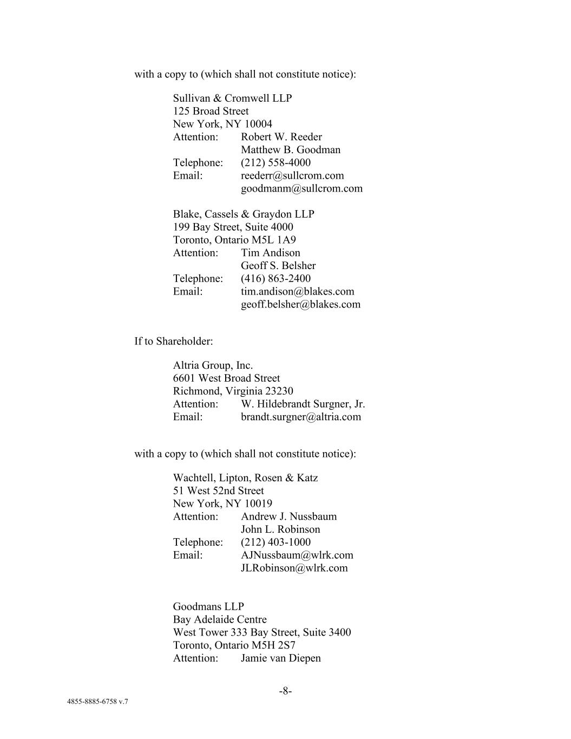
-8- 4855-8885-6758 v.7 with a copy to (which shall not constitute notice): Sullivan & Cromwell LLP 125 Broad Street New York, NY 10004 Attention: Robert W. Reeder Matthew B. Goodman Telephone: (212) 558-4000 Email: reederr@sullcrom.com goodmanm@sullcrom.com Blake, Cassels & Graydon LLP 199 Bay Street, Suite 4000 Toronto, Ontario M5L 1A9 Attention: Tim Andison Geoff S. Belsher Telephone: (416) 863-2400 Email: tim.andison@blakes.com geoff.belsher@blakes.com If to Shareholder: Altria Group, Inc. 6601 West Broad Street Richmond, Virginia 23230 Attention: W. Hildebrandt Surgner, Jr. Email: brandt.surgner@altria.com with a copy to (which shall not constitute notice): Wachtell, Lipton, Rosen & Katz 51 West 52nd Street New York, NY 10019 Attention: Andrew J. Nussbaum John L. Robinson Telephone: (212) 403-1000 Email: AJNussbaum@wlrk.com JLRobinson@wlrk.com Goodmans LLP Bay Adelaide Centre West Tower 333 Bay Street, Suite 3400 Toronto, Ontario M5H 2S7 Attention: Jamie van Diepen

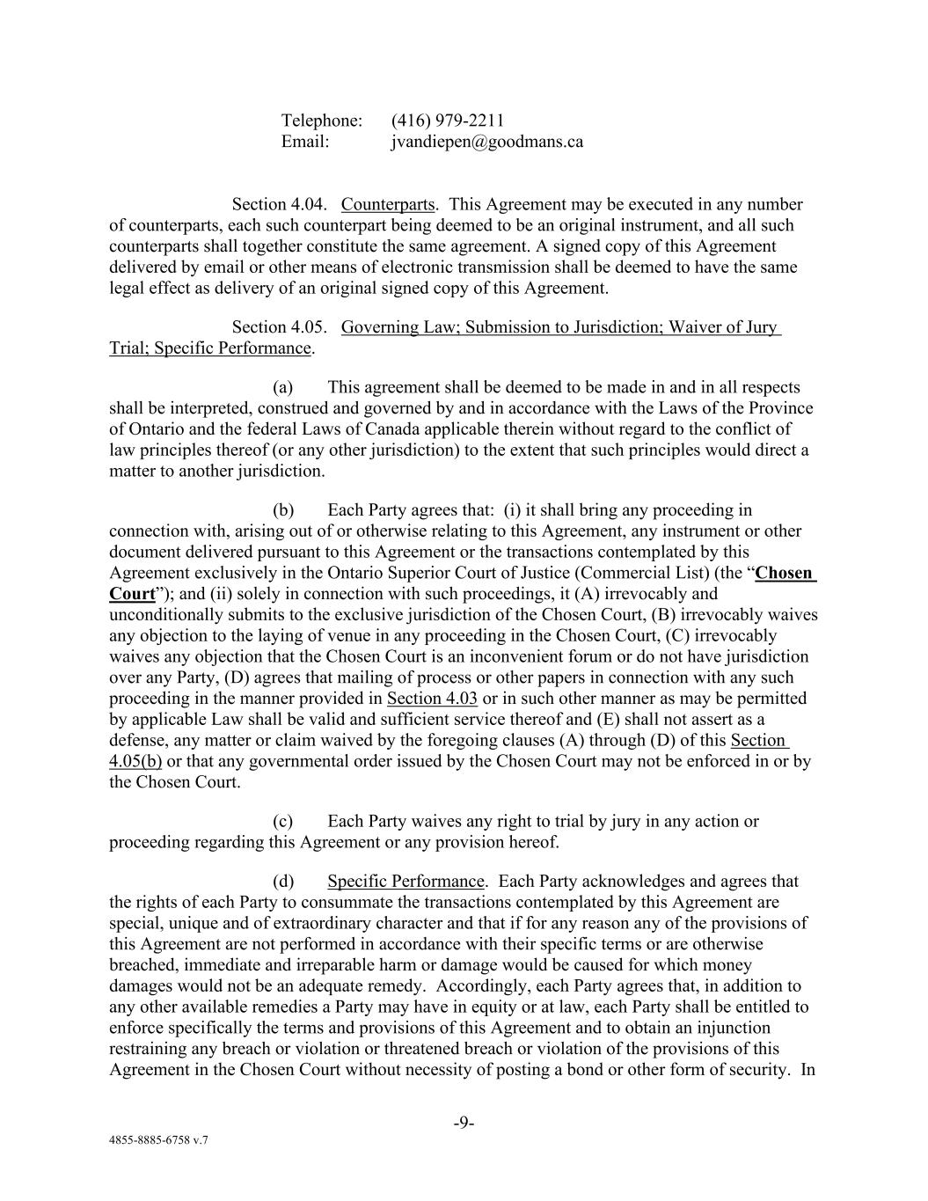
-9- 4855-8885-6758 v.7 Telephone: (416) 979-2211 Email: jvandiepen@goodmans.ca Section 4.04. Counterparts. This Agreement may be executed in any number of counterparts, each such counterpart being deemed to be an original instrument, and all such counterparts shall together constitute the same agreement. A signed copy of this Agreement delivered by email or other means of electronic transmission shall be deemed to have the same legal effect as delivery of an original signed copy of this Agreement. Section 4.05. Governing Law; Submission to Jurisdiction; Waiver of Jury Trial; Specific Performance. (a) This agreement shall be deemed to be made in and in all respects shall be interpreted, construed and governed by and in accordance with the Laws of the Province of Ontario and the federal Laws of Canada applicable therein without regard to the conflict of law principles thereof (or any other jurisdiction) to the extent that such principles would direct a matter to another jurisdiction. (b) Each Party agrees that: (i) it shall bring any proceeding in connection with, arising out of or otherwise relating to this Agreement, any instrument or other document delivered pursuant to this Agreement or the transactions contemplated by this Agreement exclusively in the Ontario Superior Court of Justice (Commercial List) (the “Chosen Court”); and (ii) solely in connection with such proceedings, it (A) irrevocably and unconditionally submits to the exclusive jurisdiction of the Chosen Court, (B) irrevocably waives any objection to the laying of venue in any proceeding in the Chosen Court, (C) irrevocably waives any objection that the Chosen Court is an inconvenient forum or do not have jurisdiction over any Party, (D) agrees that mailing of process or other papers in connection with any such proceeding in the manner provided in Section 4.03 or in such other manner as may be permitted by applicable Law shall be valid and sufficient service thereof and (E) shall not assert as a defense, any matter or claim waived by the foregoing clauses (A) through (D) of this Section 4.05(b) or that any governmental order issued by the Chosen Court may not be enforced in or by the Chosen Court. (c) Each Party waives any right to trial by jury in any action or proceeding regarding this Agreement or any provision hereof. (d) Specific Performance. Each Party acknowledges and agrees that the rights of each Party to consummate the transactions contemplated by this Agreement are special, unique and of extraordinary character and that if for any reason any of the provisions of this Agreement are not performed in accordance with their specific terms or are otherwise breached, immediate and irreparable harm or damage would be caused for which money damages would not be an adequate remedy. Accordingly, each Party agrees that, in addition to any other available remedies a Party may have in equity or at law, each Party shall be entitled to enforce specifically the terms and provisions of this Agreement and to obtain an injunction restraining any breach or violation or threatened breach or violation of the provisions of this Agreement in the Chosen Court without necessity of posting a bond or other form of security. In

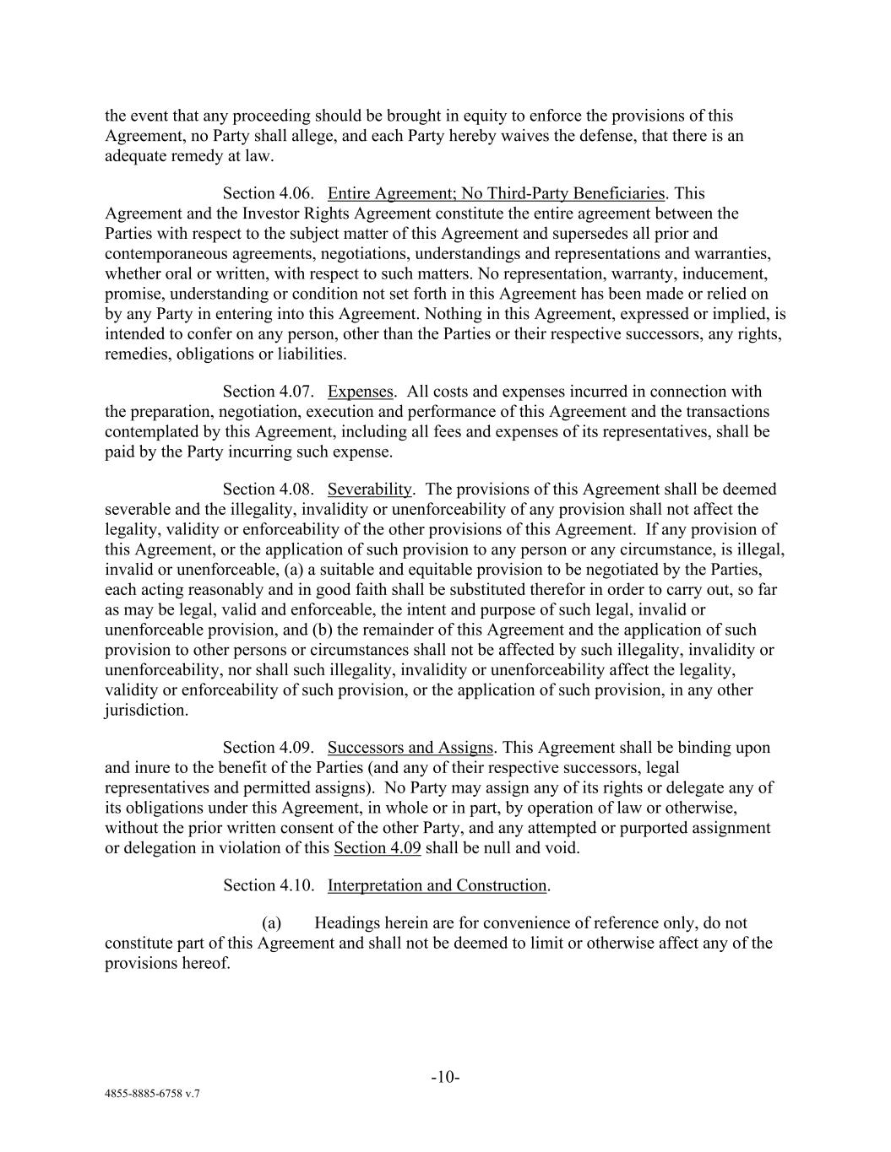
-10- 4855-8885-6758 v.7 the event that any proceeding should be brought in equity to enforce the provisions of this Agreement, no Party shall allege, and each Party hereby waives the defense, that there is an adequate remedy at law. Section 4.06. Entire Agreement; No Third-Party Beneficiaries. This Agreement and the Investor Rights Agreement constitute the entire agreement between the Parties with respect to the subject matter of this Agreement and supersedes all prior and contemporaneous agreements, negotiations, understandings and representations and warranties, whether oral or written, with respect to such matters. No representation, warranty, inducement, promise, understanding or condition not set forth in this Agreement has been made or relied on by any Party in entering into this Agreement. Nothing in this Agreement, expressed or implied, is intended to confer on any person, other than the Parties or their respective successors, any rights, remedies, obligations or liabilities. Section 4.07. Expenses. All costs and expenses incurred in connection with the preparation, negotiation, execution and performance of this Agreement and the transactions contemplated by this Agreement, including all fees and expenses of its representatives, shall be paid by the Party incurring such expense. Section 4.08. Severability. The provisions of this Agreement shall be deemed severable and the illegality, invalidity or unenforceability of any provision shall not affect the legality, validity or enforceability of the other provisions of this Agreement. If any provision of this Agreement, or the application of such provision to any person or any circumstance, is illegal, invalid or unenforceable, (a) a suitable and equitable provision to be negotiated by the Parties, each acting reasonably and in good faith shall be substituted therefor in order to carry out, so far as may be legal, valid and enforceable, the intent and purpose of such legal, invalid or unenforceable provision, and (b) the remainder of this Agreement and the application of such provision to other persons or circumstances shall not be affected by such illegality, invalidity or unenforceability, nor shall such illegality, invalidity or unenforceability affect the legality, validity or enforceability of such provision, or the application of such provision, in any other jurisdiction. Section 4.09. Successors and Assigns. This Agreement shall be binding upon and inure to the benefit of the Parties (and any of their respective successors, legal representatives and permitted assigns). No Party may assign any of its rights or delegate any of its obligations under this Agreement, in whole or in part, by operation of law or otherwise, without the prior written consent of the other Party, and any attempted or purported assignment or delegation in violation of this Section 4.09 shall be null and void. Section 4.10. Interpretation and Construction. (a) Headings herein are for convenience of reference only, do not constitute part of this Agreement and shall not be deemed to limit or otherwise affect any of the provisions hereof.

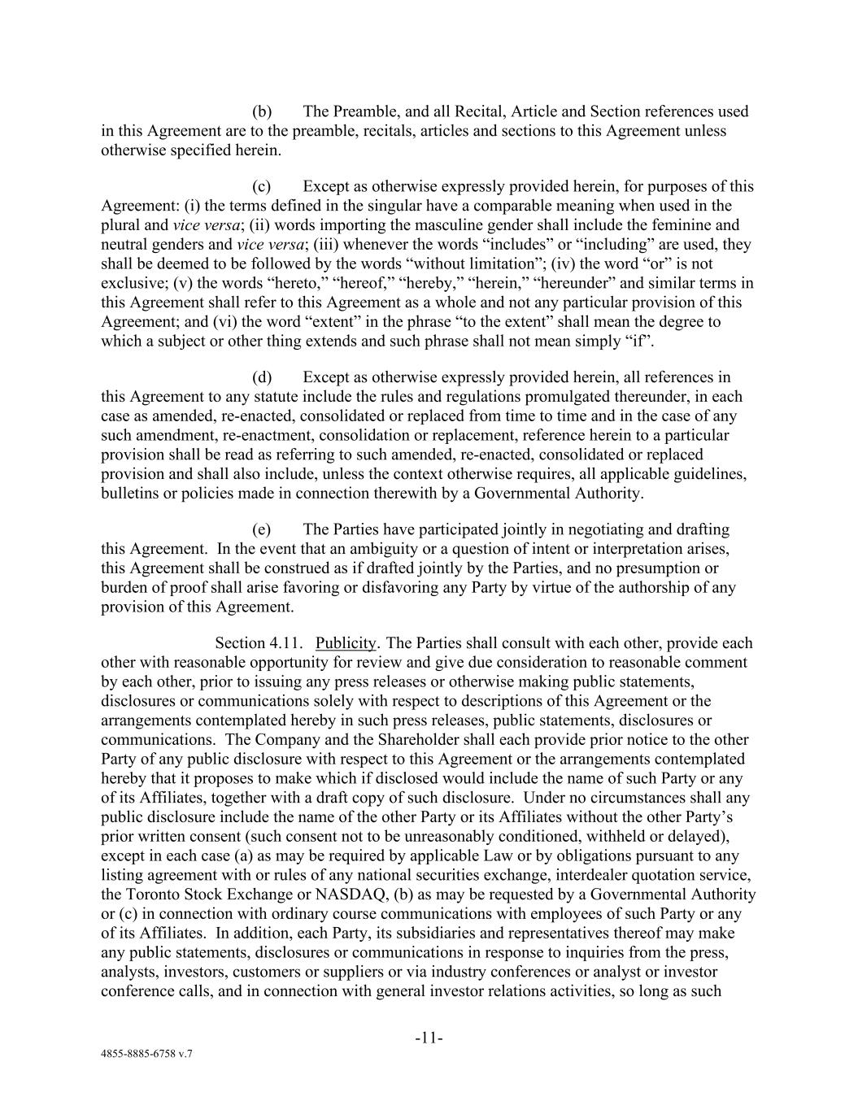
-11- 4855-8885-6758 v.7 (b) The Preamble, and all Recital, Article and Section references used in this Agreement are to the preamble, recitals, articles and sections to this Agreement unless otherwise specified herein. (c) Except as otherwise expressly provided herein, for purposes of this Agreement: (i) the terms defined in the singular have a comparable meaning when used in the plural and vice versa; (ii) words importing the masculine gender shall include the feminine and neutral genders and vice versa; (iii) whenever the words “includes” or “including” are used, they shall be deemed to be followed by the words “without limitation”; (iv) the word “or” is not exclusive; (v) the words “hereto,” “hereof,” “hereby,” “herein,” “hereunder” and similar terms in this Agreement shall refer to this Agreement as a whole and not any particular provision of this Agreement; and (vi) the word “extent” in the phrase “to the extent” shall mean the degree to which a subject or other thing extends and such phrase shall not mean simply “if”. (d) Except as otherwise expressly provided herein, all references in this Agreement to any statute include the rules and regulations promulgated thereunder, in each case as amended, re-enacted, consolidated or replaced from time to time and in the case of any such amendment, re-enactment, consolidation or replacement, reference herein to a particular provision shall be read as referring to such amended, re-enacted, consolidated or replaced provision and shall also include, unless the context otherwise requires, all applicable guidelines, bulletins or policies made in connection therewith by a Governmental Authority. (e) The Parties have participated jointly in negotiating and drafting this Agreement. In the event that an ambiguity or a question of intent or interpretation arises, this Agreement shall be construed as if drafted jointly by the Parties, and no presumption or burden of proof shall arise favoring or disfavoring any Party by virtue of the authorship of any provision of this Agreement. Section 4.11. Publicity. The Parties shall consult with each other, provide each other with reasonable opportunity for review and give due consideration to reasonable comment by each other, prior to issuing any press releases or otherwise making public statements, disclosures or communications solely with respect to descriptions of this Agreement or the arrangements contemplated hereby in such press releases, public statements, disclosures or communications. The Company and the Shareholder shall each provide prior notice to the other Party of any public disclosure with respect to this Agreement or the arrangements contemplated hereby that it proposes to make which if disclosed would include the name of such Party or any of its Affiliates, together with a draft copy of such disclosure. Under no circumstances shall any public disclosure include the name of the other Party or its Affiliates without the other Party’s prior written consent (such consent not to be unreasonably conditioned, withheld or delayed), except in each case (a) as may be required by applicable Law or by obligations pursuant to any listing agreement with or rules of any national securities exchange, interdealer quotation service, the Toronto Stock Exchange or NASDAQ, (b) as may be requested by a Governmental Authority or (c) in connection with ordinary course communications with employees of such Party or any of its Affiliates. In addition, each Party, its subsidiaries and representatives thereof may make any public statements, disclosures or communications in response to inquiries from the press, analysts, investors, customers or suppliers or via industry conferences or analyst or investor conference calls, and in connection with general investor relations activities, so long as such


-12- 4855-8885-6758 v.7 statements, disclosures or communications are not inconsistent in tone and substance with public statements, disclosures or communications previously approved by the Parties with respect to this Agreement and the arrangements contemplated hereby. [Signature Page Follows]

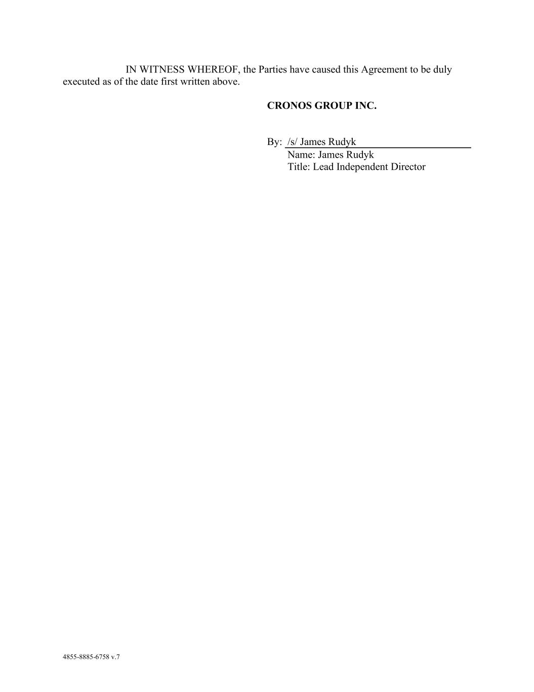
4855-8885-6758 v.7 IN WITNESS WHEREOF, the Parties have caused this Agreement to be duly executed as of the date first written above. CRONOS GROUP INC. By: /s/ James Rudyk Name: James Rudyk Title: Lead Independent Director

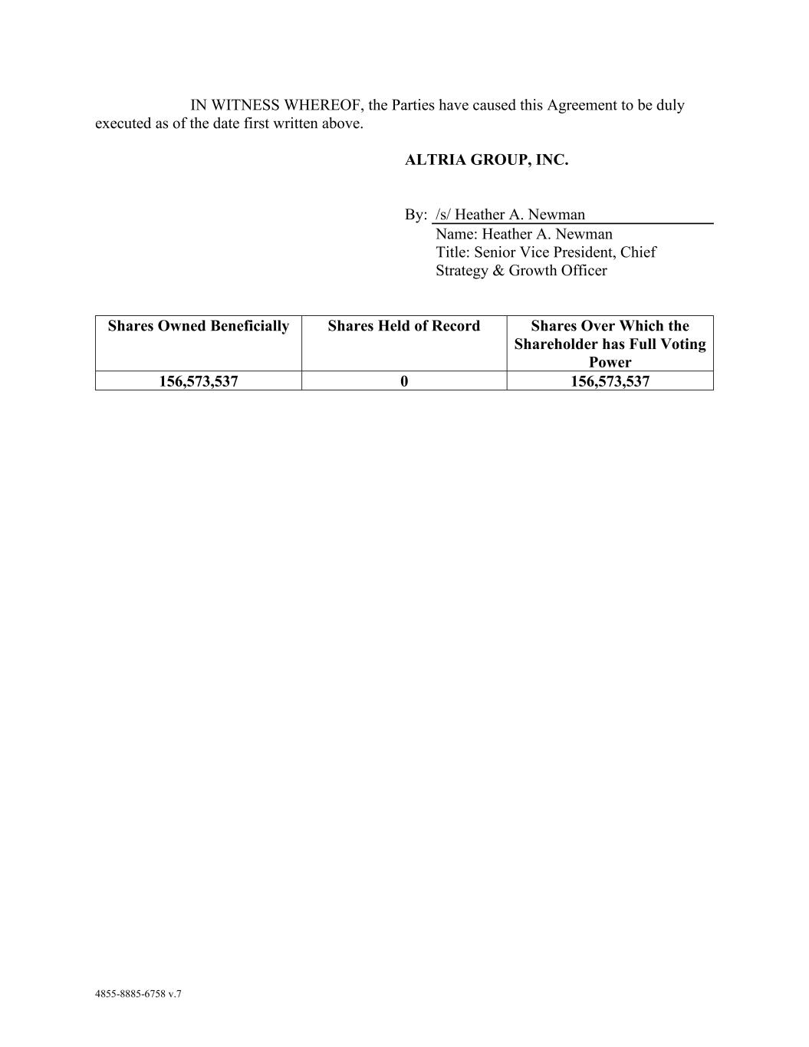
4855-8885-6758 v.7 IN WITNESS WHEREOF, the Parties have caused this Agreement to be duly executed as of the date first written above. ALTRIA GROUP, INC. By: /s/ Heather A. Newman Name: Heather A. Newman Title: Senior Vice President, Chief Strategy & Growth Officer Shares Owned Beneficially Shares Held of Record Shares Over Which the Shareholder has Full Voting Power 156,573,537 0 156,573,537

